ASIA PACIFIC UNIVERSITY OF TECHNOLOGY & INNOVATION


Implementation of Secure System
Individual Assignment

Hand-out date: Week 6
Due date: Week 14

INTAKE CODE: APD2F2502CS(CYB)

Name: RAKOTOBE Voahajatiana Eddy
TP Number: Tp079670

Table of content

I. Introduction 2

II. Focus Area 5

III- Tools and Strategies 7

IV- Implementation 8

V- Testing and Evaluation 15

VI- Conclusion 25

Reflection 26

Introduction

Network security is now one of the most important elements of an organization infrastructure in the modern digital age. With businesses, governments, and individuals becoming increasingly reliant on business systems that are interconnected, protecting network resources and communications against malicious actors has become a technical requirement and a strategic mandatory. Network security is defined as the policies, technology and processes that are aimed at ensuring data integrity, privacy, and availability over digital networks. The main aim is to ensure that network services are not accessed, abused, altered or denied to unauthorised individuals, to make sure that the efficient and safe running of the network by legitimate users is achieved.

The current networks make it possible to support the huge variety of operations, including cloud computing and online transactions, industrial control networks and IoT communications. They have therefore been an attractive target of the cybercriminals aiming to take advantage of the vulnerabilities to make money, spy on them, or disrupt them. The recent rise in cyber-attacks worldwide including ransomware, distributed denial-of-service (DDoS), phishing, and compromise of supply chains highlights the urgency of introducing a strong network security. Recent research suggests that the rate and complexity of attacks has experienced exponential growth and attackers are using automation, artificial intelligence (AI) and encryption to circumvent conventional defenses.

Network security should not just be seen as protection of hardware or data. It guarantees trust, reliability and survival in online interactions. One security breach can be so disastrous that it will result in losses of money, reputations, and even national security. Here, the resilience and credibility of any digital ecosystem is required by securing the network resources (servers, routers, storage systems, APIs and applications) and network communications (web traffic, email messages, and interactions between IoT devices).

- New Problems and Concerns:

The current network environments are intricate, diffused and dynamic than ever before. The use of cloud-based frameworks, distance working and bring your own work (BYOD) policies has greatly increased the attack surface. The classic perimeter-focused security models are also becoming insufficient due to the ability of the current threats to be external and internal-based. As an example, an employee system that has been compromised or misconfigured cloud service can give an entry point to attackers to important systems.

Among the most urgent issues of present network security, there are:
- Raised to Serious: Advanced Persistent Threats (APTs):

Long term stealth attacks by attackers are meant to obtain sensitive information without raising any alarms..
- Zero-Day Vulnerabilities:

When new vulnerabilities in software or protocols are found, the code is used prior to the release of a patch thus exposing systems to these vulnerabilities.
- Human Factor and System Set-up:

Advanced technologies notwithstanding, incorrectly configured firewalls, having weak passwords, or missing updates are still the top causes of breaches.

- Weaknesses and Susceptibilities.

The number of vulnerabilities that can be used to compromise a network is immense with most of them being caused by the use of obsolete software, insecure settings, or unprotected lines of communication. All these weaknesses give attackers loopholes to execute different types of exploits. These are the possible attack vectors that should be known in order to create a defense strategy.

The typical network weaknesses are:
- Open or Misconfigured Services:

Unhardened exposed services (e.g. HTTP, DNS, or FTP) can be used to conduct reconnaissance or execute a remote attack.
- Insecure Protocols:

Older protocols like the Telnet or unencrypted HTTP reveal sensitive data between two points.
- Insufficient Network Segmentation:

When internal networks are flat, a single compromised host can provide lateral movement opportunities for an attacker.

- Typical attacks that use vulnerabilities

- Reconnaissance Scans:

The attackers do network scan (e.g., SYN scan, ping sweep) to determine active hosts and open ports.
- Denial-of-Service Attacks (DoS):

Flooding a target with excessive traffic to exhaust system resources and make legitimate access impossible.
- Brute-Force Attacks:

Intensive authentication to services likes SSH or FTP in order to brute forces the user with valid credentials.

Altogether, the network security is the cornerstone of the digital trust and organizational stability. The increased numbers of multi-vector attacks, which are more complex, denote the need to implement both preventative and detective security solutions. Although firewalls, encryption, and access controls are a defence in the first line, Intrusion Detection Systems (IDS) are a second layer that is critical and is constantly monitoring, analysing and reporting suspicious activity in the network.

In this report, it will be necessary to implement and test an open-source IDS, Suricata, within a simulated environment to identify and respond to real-life attack cases. In this practical illustration, the study will demonstrate how a rule based detection, traffic inspection, and alert analysis can be used to effectively secure network resources as well as communications.

Focus Area
The current project is devoted to finding the practical application and testing of Intrusion Detection Systems (IDS) as an important element of contemporary network protection systems. Out of the diverse set of tools in the network monitoring and attack detection process, the research will highlight the use of Suricata, which is an open-source, high-performance IDS/IPS (Intrusion Detection and Prevention System) written by the Open Information Security Foundation (OISF). The emphasis is to learn how Suricata works in the detection and analysis of suspicious network traffic, in addition to assessing its capabilities in revealing the common attack patterns like the ICMP floods, SSH brute-force attacks and web based attacks.
The choice of the IDS as the major area of focus is explained by the growing demand of real-time network monitoring and proactive threat detection. In comparison to other preventive means like firewalls which only filter or block the traffic according to a set of pre-defined rules, an IDS offers deep packet inspection and continuous monitoring features that may unmask concealed threats in the legitimate network traffic. This renders the use of IDS solutions to be inevitable in settings in which security teams need to identify, examine, and react to intricate, transformative attacks that tend to circumvent traditional safeguards.

In particular, the scope of the given project includes the following aspects:
- Configuration and Rule Management:
The use of modified detection policies in Suricata to detect different situations of network attacks, including: ICMP echo requests (ping sweeps), SSH brute-force requests, and web access by unauthorized people. The configuration process illustrates how the accuracy of detection by fine-tuning of rules and false positives are reduced.
- Traffic: Simulation and Testing:
Creating controlled attacks in a virtual setting and monitoring Suricata behaviours with real-time attacks. In these simulations, there are benign and malicious network activities to determine the capability of the system to identify between normal and suspicious behaviour.
- Alerts Analysis and Reporting:
Testing the detection of recorded incidents using Suricata logs, which is the classification and reporting of events. This involves the analysis of the output files like the fast.log and eve.json to understand the alerts and match them with the matching attack events.

The project will close the gap between theory and practice in the field of network security by focusing on the implementation and use of Suricata. This area of interest does not only show the technical procedures on how an IDS can be established but also shows the more extended meaning of network monitoring in an organization that need resilience to changes in cyber threats.
Finally, the idea is to demonstrate how open-source software, such as Suricata, can enable security professionals to identify and prevent possible attacks before they turn into major breaches, which supports the importance of IDS in the multi-layers framework of the current cybersecurity.

Tools and Strategies

Tool / Strategy | Purpose | Advantages | Limitations
Suricata IDS | Open-source network IDS/IPS/NSM engine for real-time traffic analysis and intrusion detection | Multi-threaded, supports multiple protocols (HTTP, DNS, SSH, TLS), JSON logging, rule-based detection | Requires tuning and custom rules for accuracy
Kali Linux (attacker) | Attack simulation (ping flood, SSH brute force, port scan) | Provides pre-installed offensive tools | May generate too much noise if not configured properly
Ubuntu Server (target) | Host system for IDS monitoring | Stable, easy to configure | Needs manual network configuration

The implemented strategy combined targeted rule engineering, controlled traffic generation, and iterative validation to produce reliable detections for four attack vectors: SSH, TCP-SYN reconnaissance, ICMP probing, and HTTP suspicious requests. Custom Suricata rules were authored to be protocol-aware—using http.uri/http.method for HTTP, TCP flag inspection for SYN scans, SSH indicators for authentication attempts, and ICMP type/behavior for ping activity—and each rule was given descriptive msg text, a unique SID, and an appropriate classtype to aid triage. To reduce noise, thresholding constructs (detection_filter and threshold) were applied so that only repeated or sustained behaviours (for example multiple failed SSH logins or rapid ping bursts) generated alerts. Next once the custom rule has been placed in the IDS, all out of place connection attempts that are identifiable by our custom rule will be identified by Suricata and will have our custom message posted in the eve.json file.

Implementation
- Installation of Suricata in Ubuntu

The first step is to install the IDS inside Ubuntu. To do so we run the command
- sudo apt update : update Ubuntu to the latest version
- run sudo apt install –y suricata jq : get super user or root permission and install suricata, if any question is asked; answer is yes

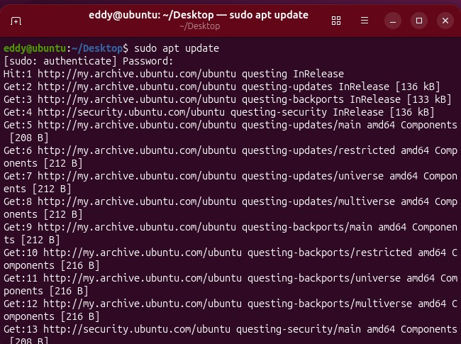
Figure 1 : Ubuntu update

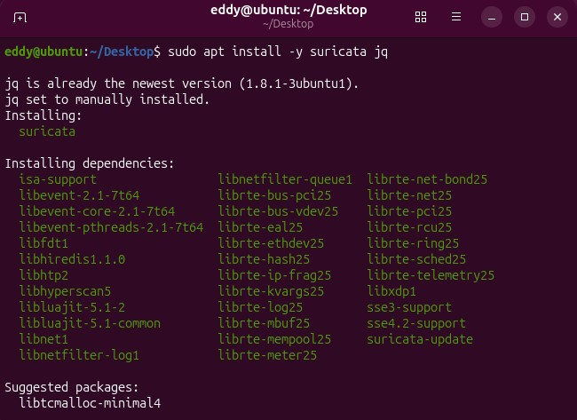
Figure 2 : Suricata installation

- Suricata –build-info : verify if suricata is installed correctly

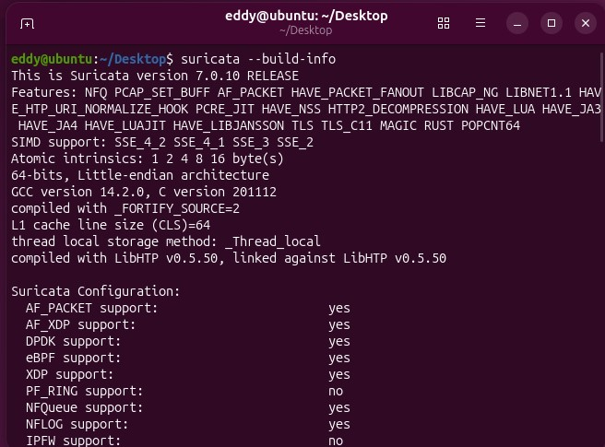
Figure 3 : Suricata verificatio
- Suricata configuration

Next, we are going to configure suricata, the first step will be to verify which network interface will be configured to use the IDS. To do that, we ran ip a.

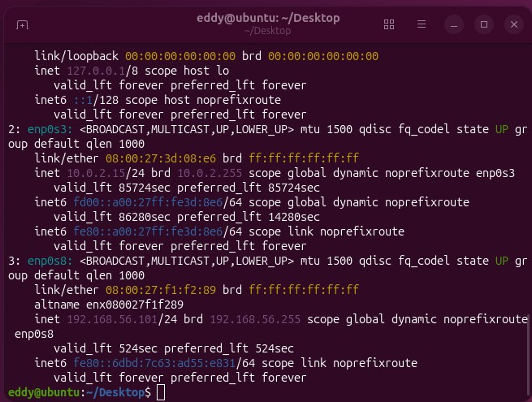
Figure 4 : Check network interface and ip address

Now we have both the ip address and the network interface information which is enp0s8. Next, we enter that interface information inside the configuration file of suricata which is found in /etc/suricata/suricata.yaml ; after entering the nano file, we insert the interface name next to interfaces configuration.

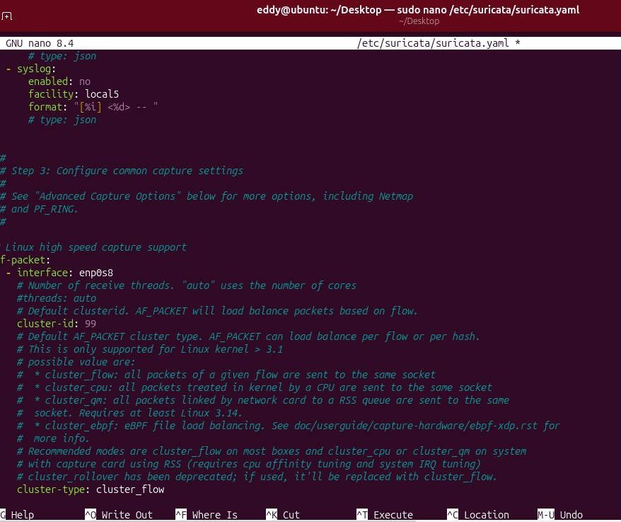
Figure 5 : Suricata file configuration for network interface

Then we run the command:
- Sudo systemctl restart suricata: it will restart suricata
- Sudo systemctl status suricata: check if suricata is working and active

- Configuration local rules for the IDS:

In fact, Suricata has his own build in or genuine rule that it is used by default by the system. For this assignment our purpose is to understand how these rules works and we will make our own custom rule. The first command to run is
- Sudo mkdir –p /etc/suricata/rules : this command create the directory named rules and if any parent directory is missing, they will be created as well.
- Sudo nano /etc/suricata/rules/local.rules : create or open (if it existed already) a nano file named local.rules, in which we will insert our custom rules

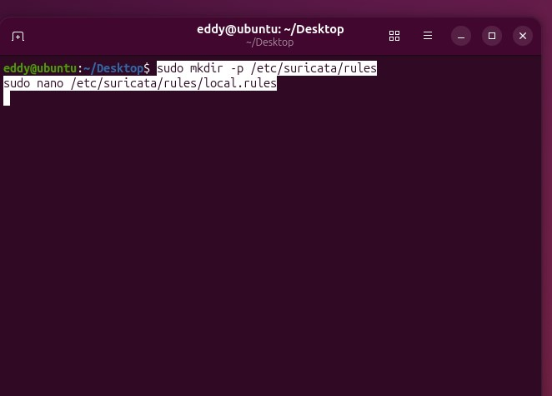
Figure 6 : Suricata rule files creation

Next we will insert our custom rules inside the nano files, for example for the SYN Scan Detection:
- alert tcp any any -> any any (msg:"CUSTOM SCAN: SYN scan detected"; \ sid:1000001; rev:1; classtype:attempted-recon; priority:2; \threshold:type both, track by_src, count 10, seconds 60; \ reference:url,https://example.local/docs/scan; metadata:policy balanced;)

Component | Description
alert | The action — triggers an alert when the rule matches. Other possible actions: drop, reject, or pass.
tcp | The protocol — this rule monitors TCP packets.
any any -> any any | Matches any source IP and port to any destination IP and port. (-> means traffic direction).
msg:"CUSTOM SCAN: SYN scan detected" | Human-readable message shown in logs when this rule triggers.
sid:1000001 | Signature ID — a unique identifier for your rule (custom rules usually start from 1,000,000).
rev:1 | Revision number — increment this when modifying the rule.
classtype:attempted-recon | Category of attack; helps in classification and reporting (e.g., recon, web-attack, dos, etc.).
priority:2 | Alert severity (1 = high, 2 = medium, 3 = low).
threshold:type both, track by_src, count 10, seconds 60 | Limits how often the rule triggers — here, if one source sends 10 packets within 60 seconds, alert once.
reference:url,https://example.local/docs/scan | Adds reference info (e.g., doc, CVE, or URL).
metadata:policy balanced | Optional tag to describe the detection policy type (informational metadata).

Purpose: Detects repeated TCP SYN packets (a sign of port scanning)

And same logic applies to every rule (HTTP, SSH, and ICMP) inside the file configuration.

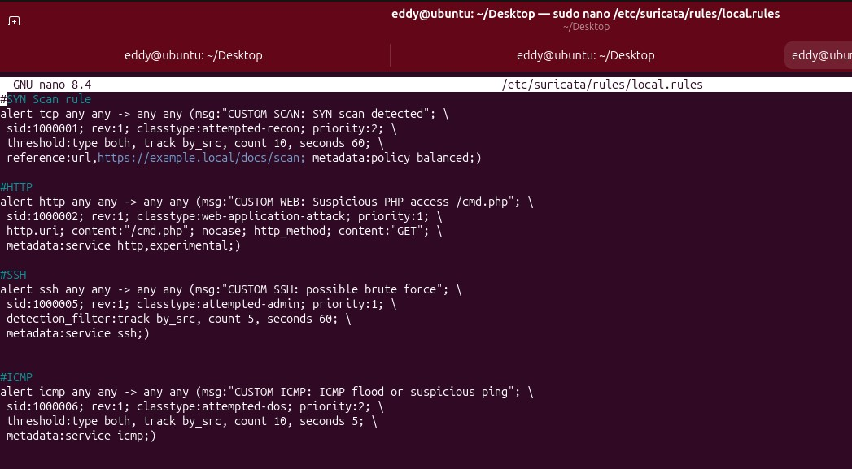
Figure 7 : Suricata custom rule

Next we need to indicate to suricata where he is going to look for our custom rules, and to do that, we are going to access the configuration /etc/suricata/suricata.yaml again and indicate the proper path to access the custom rules.

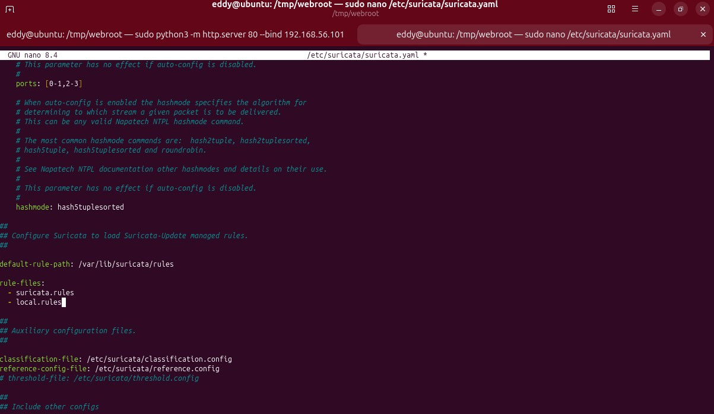
Figure 8 : Suricata configuration file for rule file
That done, the next step is to load these rule aiming that the IDS will apply the both the default rule and the custom rules. To do so we run the command: sudo suricata –T –c /etc/suricata/suricata.yaml.

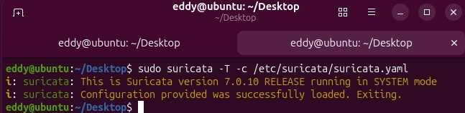
Figure 9 : Loading rule in the configuration file

Testing and Evaluation

Now that we have implemented successfully the custom rules inside the IDS, next, the rule will be tested by using Kali Linux as the attacker.

  - HTTP rules testing

The very first rule that will be tested will be the HTTP rule, to do so, it is necessary for our Ubuntu to act like a web server, and then we will create a temporary web file inside our machine for the purpose of the test.
The command to run will be
- Sudo mkdir –p /tmp/webroot : it creates a file name webroot and create any missing parent directory on the way to the path

- Echo ‘<?php echo “ok”; ?>’ | sudo tee /tmp/webroot/cmd.php > /dev/null : It creates a PHP file /tmp/webroot/cmd.php that prints “ok”, using sudo tee to write it with root permission while suppressing output

- cd /tmp/webroot : change the current working directory to webroot directory

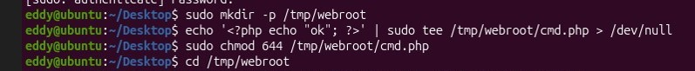
Figure 10 : Creation of temporary web file

- sudo python3 –m http.server 80 –bind 192.168.56.101: it starts a simple HTTP file server on port 80 bound to IP 192.168.56.101, serving the current directory, run as root

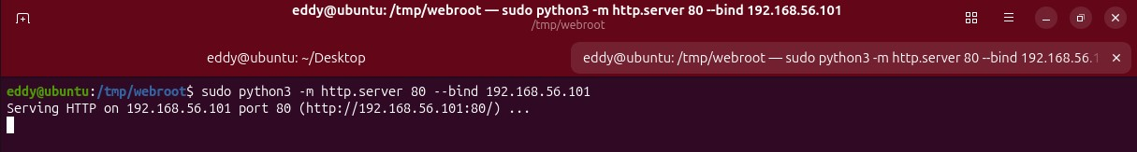
Figure 11 : Make Ubuntu act as web server

Next inside our kali linux we are going to run the command:
- curl http://192.168.56.101/cmd.php : makes an HTTP GET request to http://192.168.56.101/cmd.php and prints the response body to the terminal; 192.168.56.101 is the ip address of our target which is Ubuntu

Figure 12 : Connecting to Ubuntu via Kali

Back to our Ubuntu, now we want to see the http attack made by the Kali linux attacker, we run the command:
- sudo tail –F /var/log/suricata.eve.json | jq ‘select(.event_type== ‘alert’)’ : It continuously displays new alert events from Suricata’s eve.json log file, filtered using jq to show only lines where event_type = "alert".

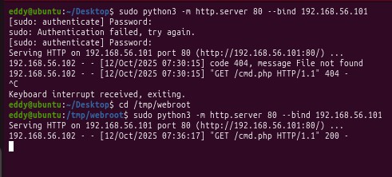
Figure 13 : Ubuntu response

Here we can see that the http GET request was successfully executed.
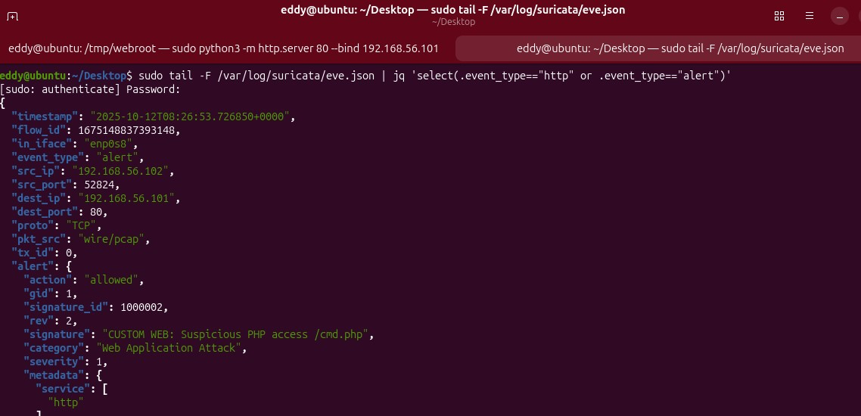
Figure 14 : Custom HTTP rule validated

Now we can see that the HTTP custom rules work correctly as it has detected our curl attack from Kali Linux since it displayed the custom rule correctly.

  - SYN custom rule
A SYN custom rule is an IDS signature, which identifies suspicious patterns of TCP SYN packets used to open connections. SYN (half open) type scans are common to attackers, in order to find available ports without having to complete the hand shaking process; thus, such reconnaissance is marked by these rules. Early detection of SYN scans provides defenders with some opportunity to investigate, log more, or prevent the origin of the scan before use. Tuning of rules (thresholds and whitelists) should be done to minimize false positive of legitimate scans or network behaviour.

Now that we know that the purpose of SYN Attack is to discover open port on a machine, we are going to perform a nmap inside Kali Linux by using the command:
- nmap –sS –sV –p- 192.168.56.101 –min-rate 1000 : Performs a fast, aggressive TCP SYN (half‑open) scan (-sS) of all ports (-p-) on the target 192.168.56.101, while also probing services to determine versions (-sV). The --min-rate 1000 forces Nmap to send packets at a minimum rate of 1000 packets/sec, making the scan much quicker but also noisier

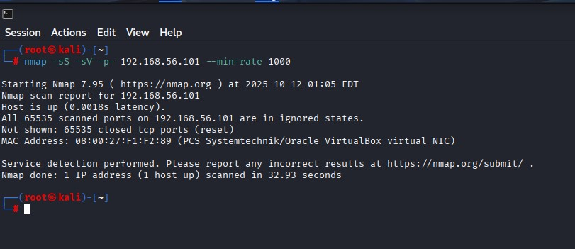
Figure 15 : Kali linux nmap scan

Then inside our Ubuntu, we check the eve.json file to see if the attack has been detected successfully.
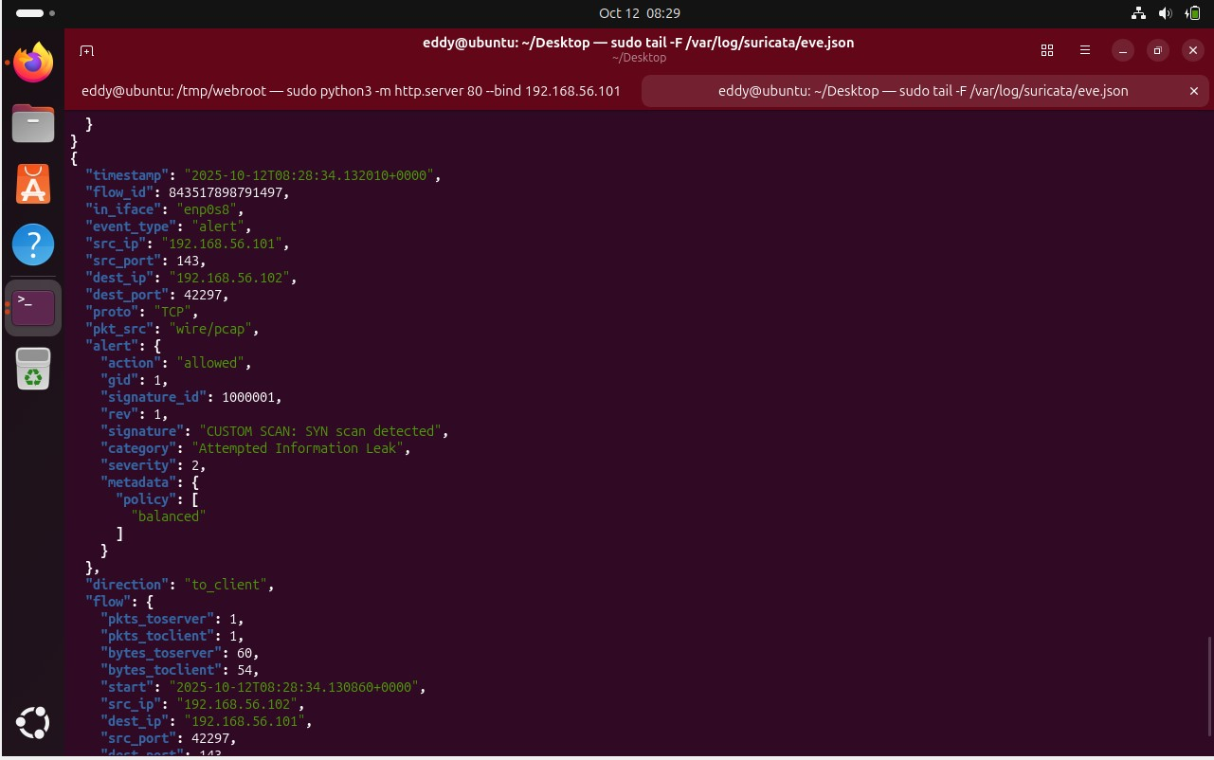
Figure 16 : SYN Custom rule validated

In this image, we can conclude that the custom rule for SYN attack is working fine inside the IDS.

  - ICMP custom rule

ICMP custom rule An IDS signature used to identify suspicious ICMP (ping) packets, e.g. odd ping floods, scans, or malformed packets. ICMP is frequently used by attackers to scan the network or verify the availability of a host, thus these rules can be used to detect reconnaissance or denial-of-service attacks. The use of ICMP activity monitoring would allow the IDS to inform the defenders before the eventual exploitation takes place through early detection of probing or attacks and responding to them appropriately, before the attack escalates to more serious levels.
To verify that our ICMP rule is working correctly, we are going to run a ping from Kali to Ubuntu. To run that, we are going to launch the command:
- Ping –c 20 192.168.56.101 : send 20 icmp packets to the Ubuntu device via the ip address 192.168.56.101

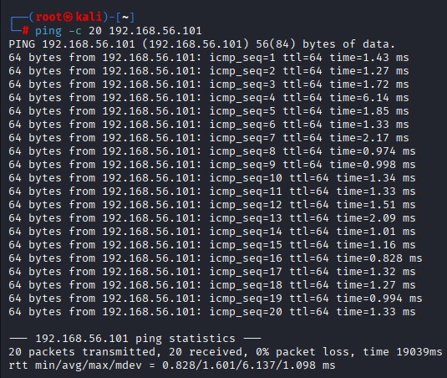
Figure 17 : Kali linux ICMP attack

Another way to validate that our custom rule is working fine inside our IDS is by looking to the log file, and to do so we can ran the command:
- Sudo tail –f /var/log/suricata/fast.log: continuously streams new entries from Suricata’s fast.log, which contains real-time alerts triggered by the IDS rules. It allows you to monitor network events as they happen, showing source/destination IPs, ports, protocols, and the specific signature that fired, enabling live analysis of suspicious traffic without manually opening the full log file.

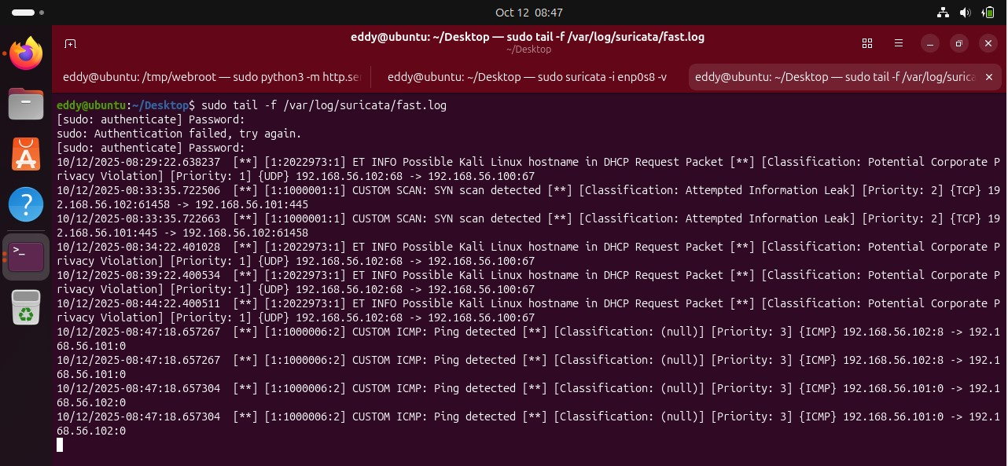
Figure 18 : ICMP attack detected

In the image, we can see that the custom rules are working fine since the message CUSTOM ICMP: Ping detected is displayed inside the log file.

  - SSH custom rules
An Intrusion Detection System has a custom SSH rule that is used to monitor and detect unauthorized or suspicious SSH traffic, including brute-force attacks on port 22 (the default SSH port) or unauthorized attempts to log-in. When the rule detects repeated attempts at connection or SSH packets received on unknown IPs, then an alert are triggered. This can be used to detect potential intrusions or scanning of secure remote access. By developing such a rule, you will be creating a rule that will actively monitor one of the most prevalent attack vectors to become a system intruder.

Now that we know the purpose of the SSH custom rules, first let’s make sure that SSH is installed and active inside our Ubuntu, otherwise the rule will not be validated if SSH is not actively running.

To do so, we use the next command:
- Sudo apt install –y openssh-serer : installing ssh in ubuntu
- Sudo systemctl enable ssh : enable ssh to work on ubuntu
- Sudo systemctl start ssh : start the ssh service
- Sudo systemctl status ssh : check if ssh is working correctly in ubuntu

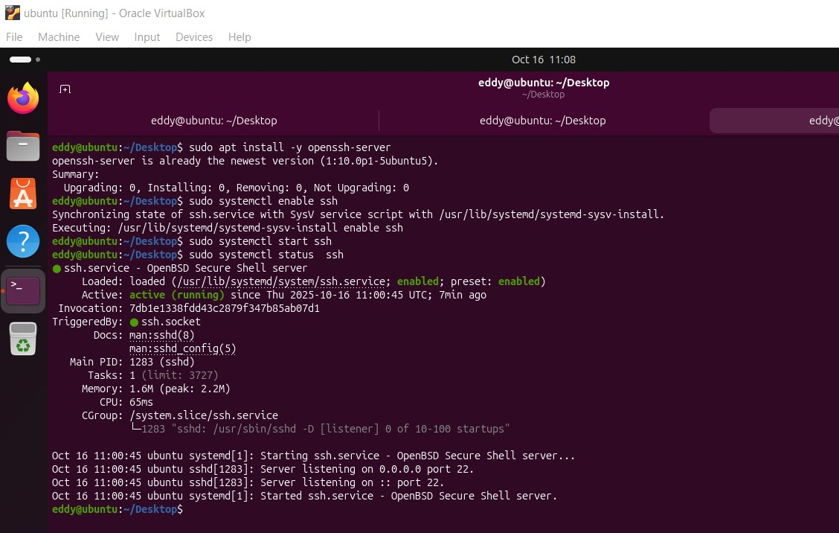
Figure 19 : SSH installation

As seen in this image, SSH service is now actively running in our Ubuntu. Next step is to try if we can connect it via Kali Linux, and see if our IDS have detected it using our custom rule. First, we run the command:
- For I in {1..6}; do ssh –o ConnectTimeout=2 nonexistent@192.168.56.101 true; done:
Command breakdown :
- for i in {1..6}; do ...; done — loop that runs the inner command 6 times.
- ssh — SSH client initiating a connection.
- -o ConnectTimeout=2 — set SSH connection timeout to 2 seconds (so hang-ups are short).
- nonexistent@192.168.56.101 — username nonexistent at target IP (intentionally invalid to force failure).
- true — remote command to run if connection succeeds (does nothing); here it ensures the client attempts an auth and then exits.

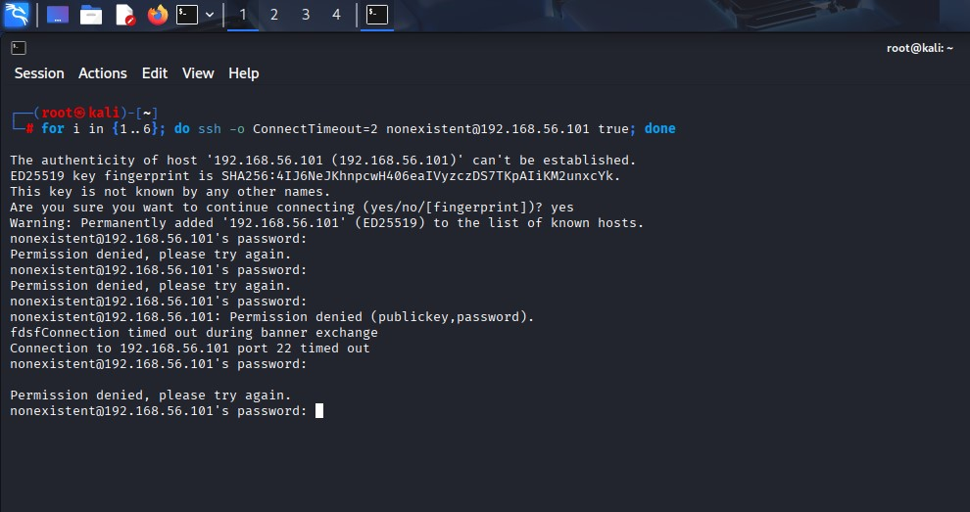
Figure 20 : SSH attack from Kali Linux

In this image, we can see that Kali Linux is trying to connect to Ubuntu via SSH, and attempting to guess the password 6 times. Now, let’s see what Suricata has detected in Ubuntu.

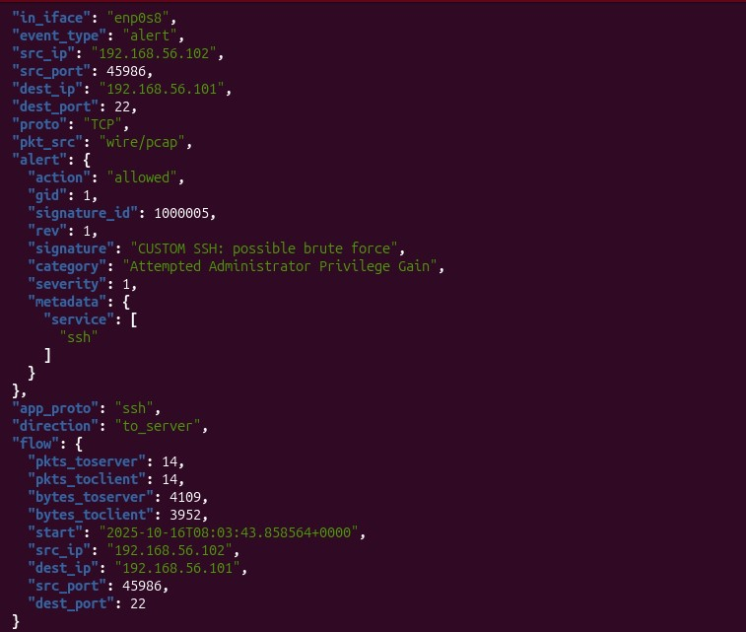
Figure 21 : SSH custom rule validated

In this image, our custom rule successfully detect the attempt SSH connection done by Kali Linux.

Conclusion

Conclusively, the present report illustrates how an intrusion detection system (IDS) can be implemented and effectively deployed with the help of Suricata as its core security control to ensure that network resources and communications are safeguarded. The study makes emphasis on active network surveillance and rule development development as it identifies four fundamental areas: SSH brute-force monitoring, SYN scan detection, ICMP flood monitoring and HTTP access scanning. These plans are the basis of identifying the patterns of malicious activities in traffic and thwarting possible intrusions before they can destroy the integrity of the system.

The outcomes of this implementation demonstrate that pattern matching, threshold-based detection, and packet inspection can be used to make network defenses much stronger. The system can detect reconnaissance and attack attempts through custom Suricata rules, which can be sent in real-time as alerts through the eve.json logging system. This allows the administrators to act quickly in response to possible threats and have consistency within operations.

Also, the experiment supports the use of IDS tools such as Suricata in the current cybersecurity designs. They are highly versatile, open-source and transparent in their visibility of traffic activities, which makes them indispensable in the enterprise and educational settings. The capability to modify detection rules based on the attack vectors of the particular attack is a guarantee of a scalable and proactive defense mechanism.

Finally, it is emphasized by the implementation that network communications need to be secured through continuous monitoring, adequate configuration, and informed decision-making. This project incorporates theoretical knowledge and empirical testing into the creation of a complete strategy to establish network confidentiality, integrity, and availability, which are the main three pillars of cybersecurity.

Reflection

This project was a good practical lesson on the application and knowledge of real-world network security practices. The experience of working with Suricata provided a better understanding of the functioning of the intrusion detection systems based on the analysis of the packets level, meaning the investigation of all the characteristics of the traffic flows to determine the presence of suspicious activity. The design and optimization of specific rules to counter attack SSH, SYN, ICMP and HTTP needed not only technical accuracy but analysis skill, which amplified the understanding of the functioning of various protocols and how attackers take advantage of their vulnerabilities.
One of the significant lessons that were learnt during the process is the trade-off between sensitivity and performance efficiency in detection. Strict settings may yield a false positive whereas lax settings may permit malicious traffic to slip through. The exercise highlighted the need to refine the rules and thresholds to generate reliable detection, without excessive use of system resources, through trial and error testing and observation.

Also, issues related to troubleshooting in the process of configuration and testing promoted a better comprehension of how network interfaces, ports and protocol interactions work. Experiencing problems related to connection refuses, rule parsing and so on reflected the real-life problem of security engineers and encouraged the importance of patience, accuracy and critical thinking.
On the professional level, the assignment equipped me with technical and conceptual competencies of cybersecurity operations. It showed that network defense goes beyond installation of tools, but involves making sense of data and trends and being adaptive to the changing threat levels. Another important lesson that the experience has taught me is the importance of the effective monitoring and proactive response systems in safeguarding organizational assets.

Overall, this reflection adheres to the path of theory to practice, the gap between the academic knowledge and the functioning of security management.

References

Network Security Vulnerabilities, Fortinet, CyberGlossary, 2025
https://www.fortinet.com/resources/cyberglossary/network-security-vulnerability

Common Types Of Network Security Vulnerabilities, Jason Firch, PurpleSec, 2024
https://purplesec.us/learn/common-network-vulnerabilities/

Types of Cyber Attacks, Fortinet, CyberGlossary, 2025
https://www.fortinet.com/resources/cyberglossary/types-of-cyber-attacks

How to Install and Configure Suricata on Ubuntu, Ahmet Aytemiz, LetsDefend, July 8, 2024
https://letsdefend.io/blog/how-to-install-and-configure-suricata-on-ubuntu

How to install Suricata on Ubuntu to secure your network, Aris S., Hostinger, 2025
https://www.hostinger.com/my/tutorials/how-to-install-suricata-on-ubuntu

Ubuntu Linux: Install the Suricata Intrusion Detection System, Jack Wallen, The New Stack, 2024
https://thenewstack.io/ubuntu-linux-install-the-suricata-intrusion-detection-system/

Adding Your Own Rules, Suricata , 2025
https://docs.suricata.io/en/latest/rule-management/adding-your-own-rules.html

Writing Effective Suricata Rules with Examples, Coralogix Team, Coralogix, 2020
https://coralogix.com/blog/writing-effective-suricata-rules-with-examples-best-practices/

How to Setup a Suricata IPS: Part 1, Critical Design Associates, 2023
https://www.criticaldesign.net/post/how-to-setup-a-suricata-ips

Writing Suricata Rules: Understanding the Basic Rule Format, Insane Cyber, 2025
https://insanecyber.com/writing-suricata-rules-understanding-the-basic-rule-format/

What is a Rule in Suricata?, Dallon Robinette, Stamus Networks, 2023
https://www.stamus-networks.com/blog/what-is-a-rule-in-suricata

What is a Ping Flood?, Imperva, 2025
https://www.imperva.com/learn/ddos/ping-icmp-flood/

